Clean Bot Specification Document

Team: Amazon FTR 5
Members: Alvin Rogers, Carolyn Winn, Nicasio Smith, Jaleel Williams



Table of Contents

- Purpose
- Overview
- User Stories (Epics & Decomposed)
- Requirements
- Traceability Matrix
- Design
- Technologies
- Front End
- Back End
- Additional Features
- Database Design
- User Interface (Mock-ups)
- Test Strategy and Test Plan
- References

1. Purpose
Outdoor environments like school campuses, residential yards, and public walkways accumulate debris, such as leaves, paper, plastic, and small waste materials, which require regular cleaning. Manual cleanup is time-consuming, inconsistent, and often infeasible for people with limited mobility, tight schedules, or large areas to maintain.

The Clean Bot is designed to fill this gap as an autonomous outdoor cleaning robot that uses LIDAR, computer vision, and path-planning algorithms to identify debris, navigate complex environments, collect waste, and send status updates to users. This solution reduces labor, supports cleaner communities, and provides an accessible, low-maintenance way to maintain the environment.

2. Overview
The Clean Bot autonomously patrols a designated area, identifies debris using machine learning models, and collects waste using a specialized intake system.

Key Capabilities:
- Autonomous Navigation: Obstacle avoidance, route planning, and return-to-dock logic using SLAM technology.
- Intelligent Perception: LIDAR + RGB camera object detection for distinguishing debris vs. obstacles.
- Debris Collection: Intake system capable of handling leaves, paper, plastic, and small trash.
- Notifications: Sends cleanup reports containing info on time, volume collected, and map coverage.
- User App: Allows starting jobs, monitoring robot status, viewing environment maps, and reviewing historical cleaning logs.

3. User Stories (Epics & Decomposed)
Epic 1: Homeowner
- US 1.1: I want the robot to identify debris so it only collects waste and avoids my plants or belongings.
- US 1.2: I want the robot to clean autonomously at certain times of day.
- US 1.3: I want the robot to avoid bumping into my vehicle or pets.
- US 1.4: I want the robot to return to its charging dock when its power is low, so I don’t have to move it there myself.
- US 1.5: I want to receive notifications when a cleaning cycle completes.

Epic 2: Beach Security Officer
- US 2.1: I want the robot to detect hazardous materials like broken glass.
- US 2.2: I want the robot to avoid going near restricted zones and beachgoers.
- US 2.3: I want real-time alerts on the robot’s current location.
- US 2.4: I want the robot to pause immediately if a person enters its safety radius.
- US 2.5: I want the robot to return to its dock for maintenance or charging.

Epic 3: Environmentalist
- US 3.1: I want the robot to sort debris by material type.
- US 3.2: I want the robot to be able to recharge using renewable energy to minimize its environmental footprint.
- US 3.3: I want the robot to avoid disrupting habitats.
- US 3.4: I want reports on the volume and types of waste collected.
- US 3.5: I want a dashboard that shows long-term trends in debris collection.

Epic 4: Groundskeeper
- US 4.1: I want the robot to identify and collect small trash.
- US 4.2: I want the robot to operate autonomously during my shift.
- US 4.3: I want to be notified when cleanup is complete.
- US 4.4: I want the robot to avoid gardens and flowerbeds and stay within a designated area.

Epic 5: University President
- US 5.1: I want the robot to identify and sort trash and debris.
- US 5.2: I want the robot to clean up campus autonomously during specific hours.
- US 5.3: I want the robot to be able to navigate campus grounds
- US 5.4: I want the robot to operate only within designated areas and avoid bumping into people.

4. Requirements
Collection
- COLLECT-01: The robot must identify and collect common outdoor debris
- COLLECT-02: The collection mechanism must be robust enough to safely handle and contain heavier or harder debris.
- COLLECT-03: The robot must have a mechanism for sorting debris by material type.

Autonomy
- AUTO-01: The system must support user-defined scheduling for autonomous operation.

Navigation
- NAV-01: The robot must navigate around obstacles to avoid moving and stationary barriers
- NAV-02: The robot must detect and temporarily adjust its path or pause operation when human presence or wildlife is in close proximity.
- GEO-01: The robot must operate within user-defined geo-fenced boundaries and cease operation if it attempts to leave.
- GEO-02: The robot must map and identify prohibited areas and navigate to exclude them from the cleaning route.

Power/Docking
- PWR-01: The robot must be able to automatically return to a designated charging or docking station upon completion or low power.
- PWR-02: The docking station must be physically secure and accessible only by authorized personnel.
- PWR-03: The robot must be powered by a rechargeable battery system, with the option for supplementary solar charging.

User Interface
- UI-01: The system must provide users with cleanup status notifications via a mobile/web interface.
- UI-02: The system must transmit real-time operational data (location, status) accessible by a central monitoring system.

Environmental
- ENV-01: The robot's movement and collection methods must be designed to avoid physical disturbance of ecologically sensitive areas.
Data/Reporting
- DATA-01: The system must generate daily reports detailing the type and estimated volume of collected debris.
- DATA-02: The collected data must be exportable in a standard format (JSON or CSV).

5. Traceability Matrix
User Story | Requirement Source | System Requirement | Design Component
1.1 | Detect and collect leaves, small debris, and lightweight trash. | COLLECT-01 | DC-M-01: Intake/Collection Mechanism (Brush Rollers & Suction) + DC-S-01: Vision System (Object Detection Model)
1.2 | Operate autonomously during scheduled hours. | AUTO-01 | DC-SW-01: Scheduler/Mission Control Module (Real-Time OS Task)
1.3 | Navigate safely around obstacles (vehicles, garden decor, pets, etc.). | NAV-01 | DC-S-02: Obstacle Sensor Suite (LIDAR or Ultrasonic) + DC-A-01: Path Planning Algorithm (DWA or RRT)
1.4 | Return to a charging dock automatically when finished or low on power. | SR-PWR-01 | DC-S-03: Docking Beacon/IR Sensor + DC-HW-01: Battery Management System (BMS)
1.5 | Provide a notification or status update when cleanup is complete. | SR-UI-01 | DC-COMM-01: Wi-Fi/Cellular Communication Module + DC-SW-02: Status Reporting API
2.1 | Detect and safely collect glass, plastic, metal, and other hazardous items. | COLLECT-02 | DC-M-02: Robust Intake System & Reinforced Waste Bin Liner
2.2 | Operate within designated zones without interfering with beachgoers or restricted areas. | SR-GEO-01 | DC-S-04: GPS Module + DC-A-02: Geo-Fencing Algorithm
2.3 | Send real-time location and activity updates to security monitoring systems. | UI-02 | DC-COMM-02: Real-time Telemetry Link + DC-SW-03: Monitoring Dashboard API
2.4 | Automatically pauses or reroutes if human presence or wildlife is detected nearby. | NAV-02 | DC-S-05: High-Resolution Cameras/Vision System + DC-A-03: People/Animal Detection Model (ML)
2.5 | Return to a secure docking station for maintenance or charging. | PWR-02 | DC-HW-02: Docking Station Physical Security (Lock/Access Control)
3.1 | Identify and sort collected debris (plastic, paper, glass, organic). | COLLECT-03 | DC-M-03: On-board Sorting Mechanism (Mechanical Arms/Conveyor) + DC-S-06: Material Sensor Array (IR/Spectroscopy)
3.2 | Operate using solar or rechargeable power to minimize environmental footprint. | PWR-03 | DC-HW-03: Solar Panel Array + DC-HW-04: High-Capacity Lithium Battery
3.3 | Avoid disrupting natural habitats, nests, or marine life near the shoreline. | ENV-01 | DC-M-04: Low Ground-Pressure Chassis Design (Wide Tires/Tracks)
3.4 | Provide daily cleanup reports with data on waste types and volumes collected. | DATA-01 | DC-SW-04: Data Logging and Report Generation Module
3.5 | Integrate with an environmental dashboard for long-term trend analysis. | DATA-02 | DC-SW-05: Data Export API (for external dashboard integration)
4.1 | Identify and collect small trash items and debris. | COLLECT-01 | (Covered by DC-M-01, DC-S-01)
4.2 | Operate autonomously during selected hours. | AUTO-01 | (Covered by DC-SW-01)
4.3 | Notify the user when cleanup is complete. | UI-01 | (Covered by DC-SW-02)
4.4 | Operate within designated areas and avoid running over gardens and flowerbeds. | GEO-02 | DC-A-04: Exclusion Zone Mapping Algorithm (User-defined map input)
5.1 | Identify and sort trash and debris. | COLLECT-03 | (Covered by DC-M-03, DC-S-06)
5.2 | Operate autonomously during selected hours. | AUTO-01 | (Covered by DC-SW-01)
5.3 | Navigate the area and can move between two different terrains. | MECH-01 | DC-M-05: All-Terrain Drive System (High-Torque Motors & Independent Suspension)
5.4 | It operates in the designated area and can avoid bumping into obstacles | GEO-01 | (Covered by DC-S-04, DC-A-02, DC-S-02, DC-A-01)

6. Design

6.1 System Architecture
The Clean Bot system consists of five primary units:
- Perception Unit:
  - LIDAR Module: For mapping and obstacle detection.
  - Camera Module: For AI object classification.
  - Logic: SLAM + AI inference pipeline.
- Action Unit:
  - Motor Drivers: Control wheel speed and direction.
  - Intake System: Controls the vacuum/brush mechanism.
- Power Unit:
  - BMS: Battery management system.
  - Charging: Auto-dock IR receiver + Optional Solar add-on.
- Cloud Services:
  - Backend: AWS for data storage.
  - Notification Services: Push alerts to mobile.
- User App:
  - Frontend: React interface.
  - Features: Live map view, Control panel.

7. Technologies
Hardware:
- LIDAR sensor (LIDAR-DC), RGB camera, Ultrasonic sensors.
- DC/Servo motors.
- Raspberry Pi for computing.
Software:
- ROS2 (Python).
- OpenCV + TensorFlow Lite for machine learning features.
- Firebase for data storage
- Lovable for web app design.
- Gazebo for the simulation environment.

8. Front End
The front end is a mobile-responsive React web app providing:
- Live visualization of the robot on the yard map.
- Battery percentage, debris bin level, and connectivity.
- Immediate Start/Pause/Stop functionality.
- Specialized view for environmentalists to track waste data.
- Drag-and-drop calendar for automated cleaning.

9. Back End
The backend infrastructure will be implemented using Flask or Node.js. This infrastructure will manage the robot's data and state:
- RESTful API for app-to-cloud communication.
- Stores logs, maps, and analytics.
- Firebase Auth for secure user management.
- HTTPS for robot-to-cloud telemetry.

10. Additional Features
- Voice Assistant Integration: Allows the robot to be activated by voice assistants like Siri or Alexa
- Solar Charging Capability: Extends battery life during outdoor idle time.
- Environmental Dashboard: Long-term analysis of collected waste types.
- Simulation Model: A digital clone of the robot for testing algorithms safely

11. Database Design
The database utilizes a NoSQL structure to handle dynamic data.

Collections & Schema: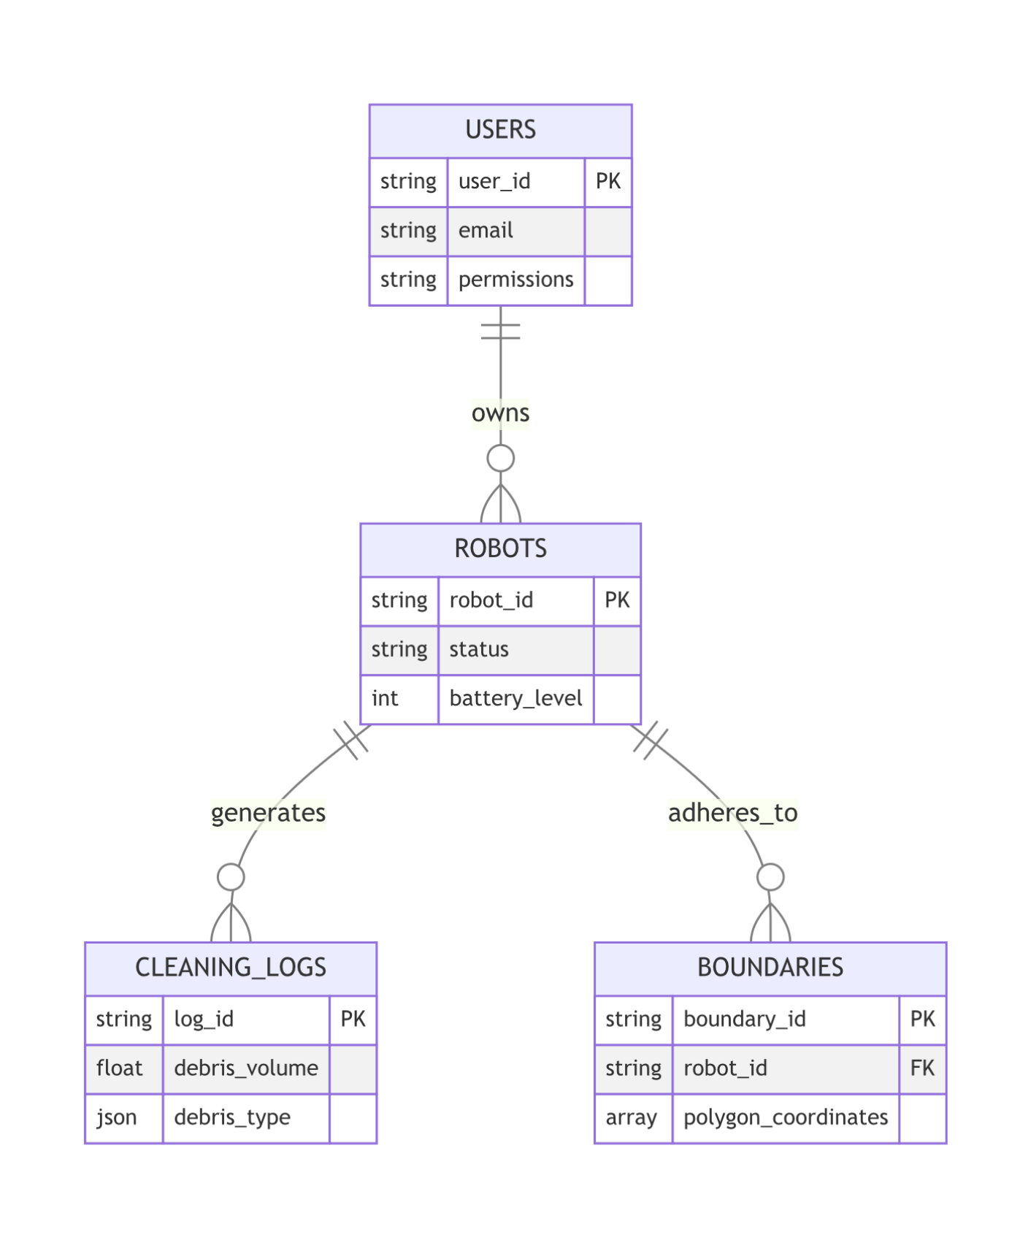

12. User Interface (Mock-ups)
Screen Descriptions:
- Login Screen: Secure entry with "Forgot Password" flow.
- Dashboard:
  - Battery indicator (Ring chart).
  - Robot status text (Idle, Cleaning, Paused, Returning).
  - Quick controls (Play/Pause/Dock).
- Map View:
  - Live robot location (Blue dot).
  - Obstacles (Red polygons).
  - Cleaned path (Green overlay).
- Reports Screen:
  - Graph: Debris collected over time.
  - Pie Chart: Material-type breakdown.
- Schedule Screen: Calendar view to set recurring jobs.
- Boundary Editor: Interactive map to draw/edit the "Keep Out" zones.

13. Test Strategy and Test Plan
We employ a 3-tier testing strategy: Unit, Integration, and System.
Unit Tests:
- Verify LIDAR is read correctly.
- Motor commands execute properly (Forward, Reverse, Stop).
- Intake system activates when the "Debris Detected" signal is true.

Integration Tests:
- LIDAR → SLAM → Path planner works end-to-end.
- Camera model correctly classifies debris from obstacles.

System/Acceptance Tests Cases:
- Place robot near flowerbed → Verify no damage occurs (Boundary check).
- Simulate low battery (14%) → Verify robot navigates to dock.
- Place debris + obstacle in path → Verify robot collects debris but avoids obstacle.
- Complete job → Verify notification sent to app.
- Block intake → Verify robot detects obstruction/stall current.
- Latency Check → Verify live map updates within 1 second.
- Boundary Violation → Verify robot stops if pushed outside the zone.

14. References
- Traceability Matrix
- Project Document

